Modular Argumentation Demonstration Users Guide

Installation
- Download and install Clingo. https://potassco.org/clingo/
- Make sure Clingo is on your system’s classpath. An easy way to check this is to open up the terminal and try to run the line “clingo”. If clingo is on the classpath, the command will be recognised.
- Install the latest version of Java. http://www.oracle.com/technetwork/java/javase/
- Run MAD by opening the terminal while in the /Mad folder and using the command:
“java Mad”

Using MAD
The program has a single screen interface through which you can build your framework, define the contents of each module, and derive results. Below is a list of its features.
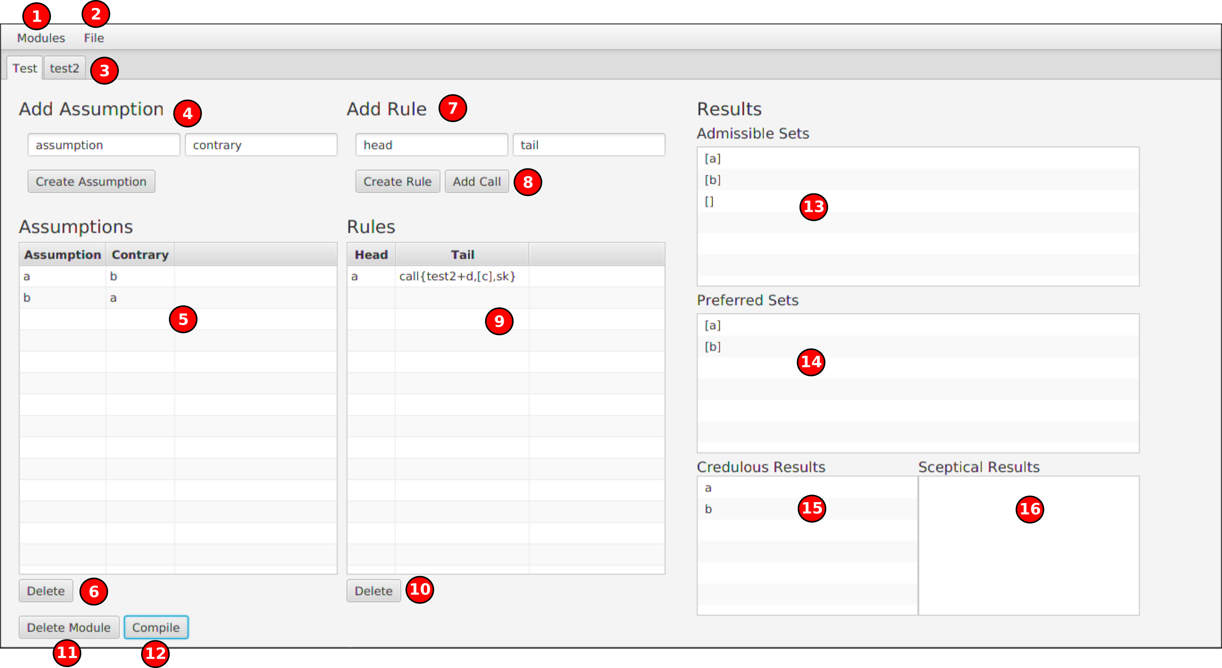
- Module menu – This menu contains the option to create new modules. When you select the “Add new module...” option, a dialog box will appear prompting you to name the module.
- File menu – This menu contains the options to save and load frameworks from file. When saving a framework, you will be prompted to name the save file. Please note that if you choose a name already in use the old framework will be overwritten.
- Module tabs – Every module is accessed through these tabs, that work much like tabs on a web browser. The contents of each module will not be lost if you tab away from it without saving.
- Adding assumptions – Enter the name of the assumption in the form box on the right, and the contrary to the assumption on the left. Once you’ve entered these, Contraries are not required to create assumptions, just leave the contrary box blank if you don’t want to include one. Contrariness is bidirectional, so if you want a contrary of an assumption to also be an assumption, you do not need to include declare the contrary again. Assumptions and contraries should be alpha-numeric, and (unless using a variable) lower case, except for brackets which are needed for predicates e.g. “bird(crow)”, and “-” for classical negation. Both negation-as-failure and classical negation can be used, the former with a prefix “not” e.g. “not bird(cow)”.
- Assumptions Table – This table contains the assumptions and contraries that have been added to the currently selected module.
- Delete Assumption button – Removes currently selected assumption (on table)
- Adding rules – Enter the head of the rule on the right, and the tail of the rule on the left. The tail can be composed of multiple sentences, as long as they are seperated by a comma. Rules can be created without tails to create facts. When using variables, make sure that any variables in the head appear in the tail, and that variables are not used in sentences beginning with “not” - misuse of variables will result in errors when modules are compiled. Rules should also obey the same formatting rules as assumptions (except in calls).
- Adding calls – Calls can be added manually, but this is not advised until the user is familiar with the syntax. The Add Call button opens up a dialogue where the user can define a call to be added to the tail:
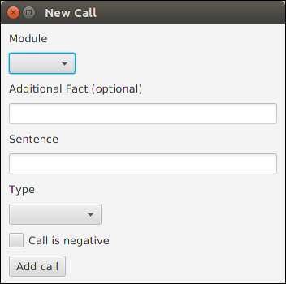

The user can choose which module the call is to (avoid making calls to the module the call is in) and add additional facts to be added to the called module when the call is resolved. The sentence is what is being checked for as a result of the called module, and the type is what type of result the sentence should be in the called module for the call to resolve as true (either credulous or sceptical). If the call is negative, this is negation-as-failure. So a credulous negative call for the sentence “isRaining” will return true if “isRaining” is not a credulous result of the called module.
- Rules Table – This table contains the rules that have been added to the currently selected module.
- Delete Rule button – Removes currently selected rule (on table).
- Delete Module button – Deletes currently viewed module.
- Compile button – Will compile currently viewed module and fill results boxes on the right. Note that any calls will be resolved first by compiling the modules called first, and so on until all calls are resolved. This will be done automatically – no need to manually compile any modules besides the one you want the results for. Results will not update if any modules are altered, but the compile button can be pressed again.
- Admissible sets – Once a module is compiled, its admissible sets are displayed here.
- Preferred sets – Once a module is compiled, its preferred sets are displayed here.
- Credulous results - Once a module is compiled, its credulous results are displayed here.
- Sceptical results - Once a module is compiled, its sceptical results are displayed here.

Included in MAD are two pre-made frameworks. The first, test.ser is a simple example framework to use as a reference when getting started. The second, sherwood.ser, is the formalisation of an example case from the paper that inspired MAD:

Phan Minh Thang and Phan Minh Dung.
“Modular Argumentation for Modelling Legal Doctrines in common law of contract”
In: Artificial Intelligence and Law
17 (2009), pp. 167–182

https://link.springer.com/article/10.1007/s10506-009-9076-x

